Chellenge
LO1 – Analyzing
Malamski,Dimitar D.S.
mitemalamata@gmail.com

Contents
Contents 1
Introduction 2
Sprints 2
Sprint 6 2
Evidence 1 - Analyzing Style Overlap for Multi-Label Classification 2
Sprint 5 3
Sprint 4 3
Evidence 1 - Project Proposal and Domain Exploration 3
Evidence 2 - Real-World Dataset Gathering and Generalization Analysis 3
Evidence 3 - Systematic Recommendation Evaluation and Error Analysis 4
Sprint 3 5
Evidence 1 – Initial Project Proposal Desing 5
Evidence 2 - Problem Decomposition and Analytical Framing 6
Evidence 3 - Dataset Design and Labeling Strategy 6
Evidence 4 - Critical Analysis of Limitations 7
Sprint 1 & 2 8

Introduction
This document presents the evidence for Learning Outcome 1 ( Analyzing ) in my Challenge project – Outfit Recommendation System. The purpose of this document is to show how I demonstrated this learning outcome through the work completed during the project. The evidence is organized by sprints, with each section describing the activity, the result, and why it is relevant to the learning outcome.

Sprints

Sprint 6

Evidence 1 - Analyzing Style Overlap for Multi-Label Classification
What this evidence is
This evidence shows how I analyzed the limitation of using single-label style classification in the outfit recommendation system.
What I did
After testing the style classifier and the recommendation system, I noticed that some clothing items were difficult to classify into only one style. This is because fashion styles can overlap. For example, one item can look both gothic and streetwear, or both sporty and streetwear. The previous model was forced to choose only one final style, even when the item could reasonably belong to more than one category.
Because of this, I analyzed the style prediction errors and ambiguous images. I looked at cases where the model made mistakes, where the confidence margin was small, and where the second predicted style was also visually reasonable. This helped me identify images that could be useful for multi-label classification. I also made sure that the real-world test set stayed separate, so it would not be used for training or relabeling.
Result
The result was a clearer understanding of one of the main limitations of the previous style model. The problem was not only that the model sometimes predicted the wrong style, but also that the single-label setup did not fully match the fashion domain. Some clothing items naturally combine multiple aesthetics, so forcing each image into only one style removed useful information.
This analysis helped prepare the dataset for multi-label learning. After reviewing the possible candidates, a multi-label training file was created with both single-label and multi-label examples. This gave the next model a better way to represent overlapping fashion styles.
Why this is relevant to the Learning Outcome
This demonstrates Analyzing because I critically examined the results of the current AI solution and identified a deeper limitation in the problem definition. Instead of only looking at accuracy, I analyzed why certain mistakes happened and connected this to the nature of fashion styles. This helped me redefine the style classification problem from a single-label task into a more realistic multi-label task.

Sprint 5
There was no work done for this learning outcome during this sprint.

Sprint 4

Evidence 1 - Project Proposal and Domain Exploration
What this evidence is
This evidence is the Project Proposal document for my Challenge project. It shows the first analysis of the fashion recommendation problem, the domain, the stakeholders, the project scope, and the analytical approach.
What I did
At the start of the project, I analyzed why outfit recommendation is difficult. I found that it is not only about recognizing clothing items, but also about understanding how items fit together based on style, color, context, texture, and personal preference. I also spoke with stakeholders to get both a fashion-related perspective and a regular user perspective. This helped me understand that recommendations need to be visually coherent, logical, and useful in real-life situations.
Result
The result was a clearer project direction. Based on the domain analysis and stakeholder input, I scoped the project down from full outfit compatibility to a more realistic approach based on predicting clothing type and style first. This gave the project a structured starting point before moving into dataset creation and modelling.
Why this is relevant to the Learning Outcome
This is relevant to Analyzing because I explored the domain and context before starting implementation. It shows that I first investigated the problem, spoke with stakeholders, considered their expectations, and defined a realistic AI direction instead of immediately building a model.

Evidence 2 - Real-World Dataset Gathering and Generalization Analysis
What this evidence is
This evidence shows how I created a separate real-world test set to evaluate the models in more realistic conditions.
What I did
After the first experiments, I noticed that the curated dataset was quite clean and controlled. Because of this, I created a real-world test set with 80 images, balanced across 4 styles and 4 clothing types. The images included more realistic conditions such as worn clothing, different lighting, and varied backgrounds.
Result
The real-world evaluation showed that the style classifier had 0.4750 accuracy, while the clothing type classifier had 0.7500 accuracy. It also showed that streetwear had 0.00 recall in the first real-world evaluation. This proved that the model performed worse in realistic conditions than on the curated dataset.
Why this is relevant to the Learning Outcome
This demonstrates Analyzing because I collected and explored extra data to test the limits of the AI solution. The results helped me identify that style prediction was the main weakness and that the dataset needed more targeted improvement.
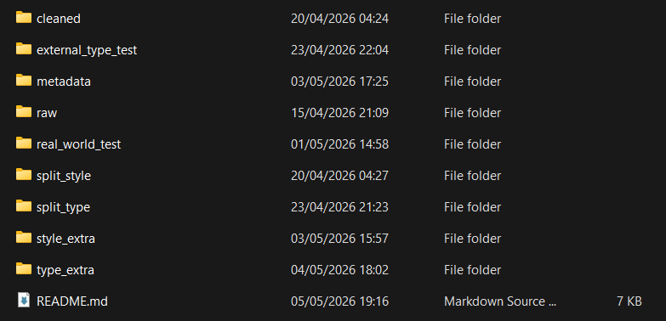
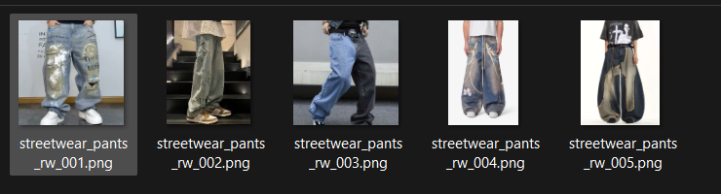

Evidence 3 - Systematic Recommendation Evaluation and Error Analysis
What this evidence is
This evidence is the final recommendation evaluation notebook, where I analyzed the recommendation results using automatic checks and manual scoring.
What I did
I selected 32 balanced examples from the real-world test set, with 2 examples for each style and clothing type combination. For each example, I recorded the true labels, predicted labels, confidence scores, safeguard status, and recommended item types. I also scored the recommendations from 0 to 2 based on structural validity, style consistency, visual coherence, warning usefulness, and overall quality.
Result
The evaluation showed that the system was strong in clothing type prediction, with 30 out of 32 correct predictions. Style prediction was weaker, with 18 out of 32 correct predictions. The average structural validity score was 1.875 out of 2, but style consistency, visual coherence, and overall quality each scored 1.3125 out of 2.
Why this is relevant to the Learning Outcome
This demonstrates Analyzing because I systematically explored the results and identified the main limitations of the system. The analysis showed that the recommendation structure was mostly reliable, but style reliability was still the main bottleneck.
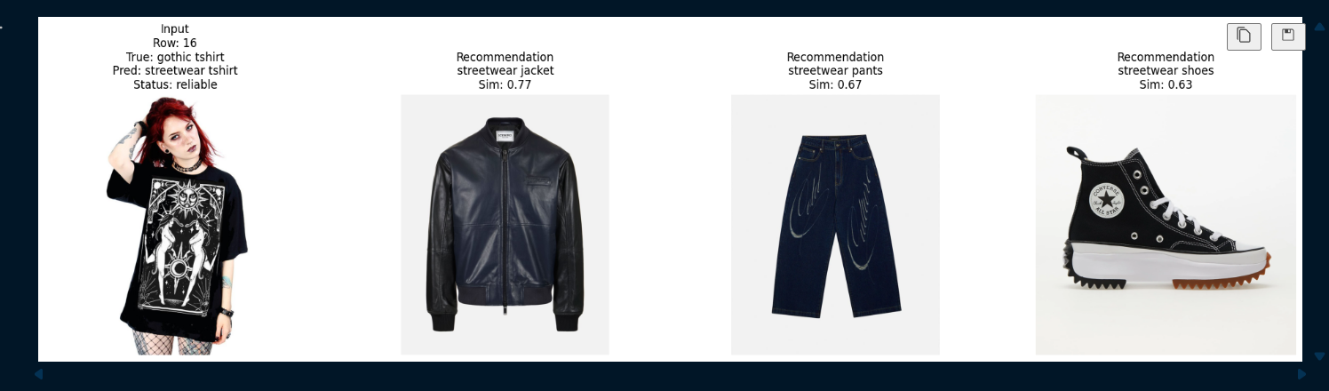
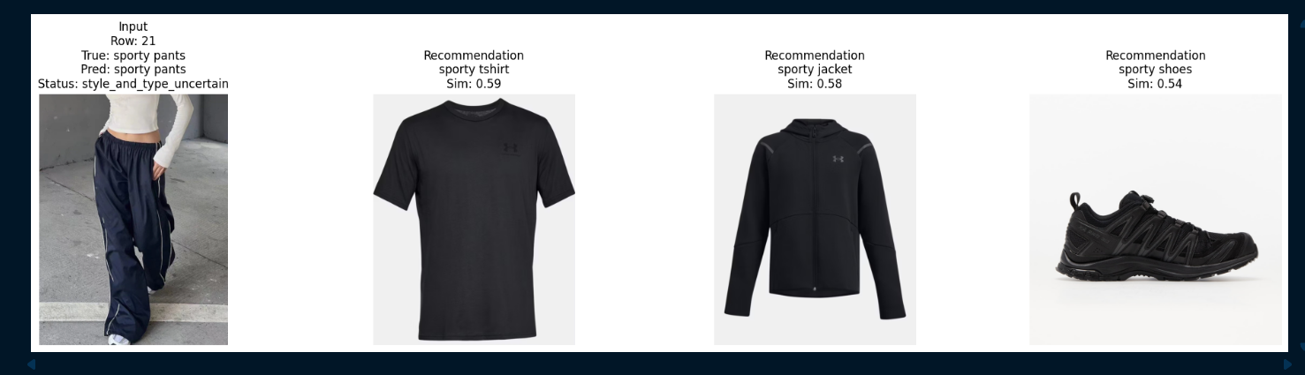

Sprint 3

Evidence 1 – Initial Project Proposal Desing
What this evidence is
After collecting feedback from the Practice Challenge, I decided to apply it in this project more properly by creating a conducted document structure as a starter.
What I did
The feedback received from the previous project was that I need to be more specific on what I am analyzing in the documentation and also to conduct everything in one singular document so it can be easier for the reader to go through it. As of now, the document is not starter, but the idea and what I am planning to do is there and also a example word document is created. I am still waiting for a feedback from a professor, before publishing it in the portfolio.
Result
The result is a simple document with an initial structure written down. For the next sprints, I am planning to go over it iteratively, every time changes to the data are done, just like the AMD methodology.
Why this is relevant to the Learning Outcome
This is relevant to this learning outcome, since it showcases that I am acting professional in creating a proper documentation for the project and also applying feedback from previous projects into this one.

Evidence 2 - Problem Decomposition and Analytical Framing
What this evidence is
This evidence shows how I analyzed the original problem of fashion recommendation and redefined it into a more manageable machine learning task.
What I did
Initially, I found a dataset that had the relationships between the items, in order to create an outfit, but after discussing it with a teacher, we concluded that it is better for me to create my own dataset and collect the images manually. That way, I will lower bias and will develop a system that initially tried to identify a style and later, I want to develop a system that correctly identifies a type of clothing. After successfully developing that, I will move to combining the two approaches to create a recommendation system. In the first notebook, developed this Sprint, I explored the style guessing problem.
Result
This resulted in a clear and structured analytical problem that could be realistically addressed with the available dataset. It provided a solid foundation for building and evaluating a first baseline model before moving to more complex recommendation tasks.
Why this is relevant to the Learning Outcome
This demonstrates analyzing because I critically examined the original problem and transformed it into a simpler and more feasible analytical task. This allowed me to approach the project in a structured and justified way.

Evidence 3 - Dataset Design and Labeling Strategy
What this evidence is
This evidence shows how I analyzed and designed the dataset structure and labeling approach for the fashion classification problem.
What I did
Instead of using an existing dataset directly, I manually curated a dataset based on two dimensions: style and clothing type. I defined clear labeling rules in advance to reduce ambiguity and ensure consistency across the dataset. I also analyzed potential challenges such as subjective style boundaries and class overlap, especially between categories like casual and streetwear. Additionally, I ensured that the dataset was balanced across all style classes and structured in a way that supports both classification and future recommendation tasks. After the first run, I decided to switch the casual style to something that is more distinguishable from the rest of the classes – gothic. As a baseline, I begin with 10 pictures in each type of clothing and later I collected 50 total for each type, so more data is present while training the model.
Result
This resulted in a clean and well-structured dataset with consistent labels and balanced class distribution. It also created a reusable dataset design that can support future extensions of the project, such as combining style and clothing type for recommendations.
Why this is relevant to the Learning Outcome
This demonstrates analyzing because I did not simply use data as given, but critically examined how it should be structured, labeled, and interpreted. This ensured that the dataset meaningfully represents the problem being solved.
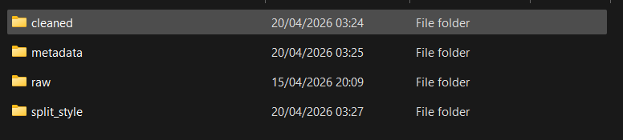
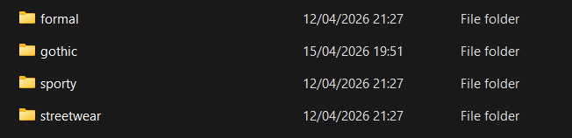

Evidence 4 - Critical Analysis of Limitations
What this evidence is
This evidence shows how I analyzed the limitations of the dataset and the baseline model.
What I did
I critically examined the dataset size, labeling process, and model performance. I identified that the dataset is relatively small, which limits generalization, and that style labels are inherently subjective, especially for overlapping categories. I also analyzed how inconsistencies in data collection, particularly for the sporty class, affected the model’s performance. Additionally, I reflected on the limitation that the current model only predicts style and does not yet address full outfit recommendation.
Result
This resulted in a clear understanding of the boundaries of the current solution. It highlighted the need for more data, improved label consistency, and further development toward recommendation-based systems.
Why this is relevant to the Learning Outcome
This demonstrates analyzing because I critically evaluated the reliability and completeness of the solution. By identifying its limitations, I ensured a more accurate interpretation of the results and defined clear directions for future work.
Addition
This analyzing was from the first run of the model which gave around 75% accuracy. After speaking with a professor, I decided to switch one of the style classes ( as mentioned above ) and also to collect more imaged for better generalization of the model.
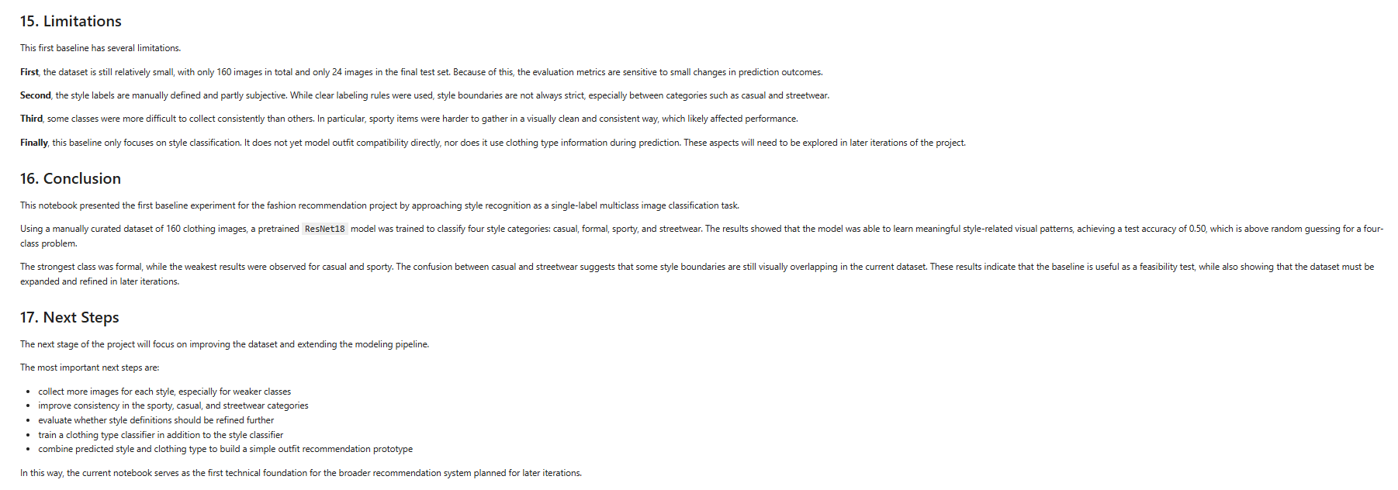

Sprint 1 & 2
There was no work done in those sprints, since the projects starts from Sprint 3.

